Question 1:
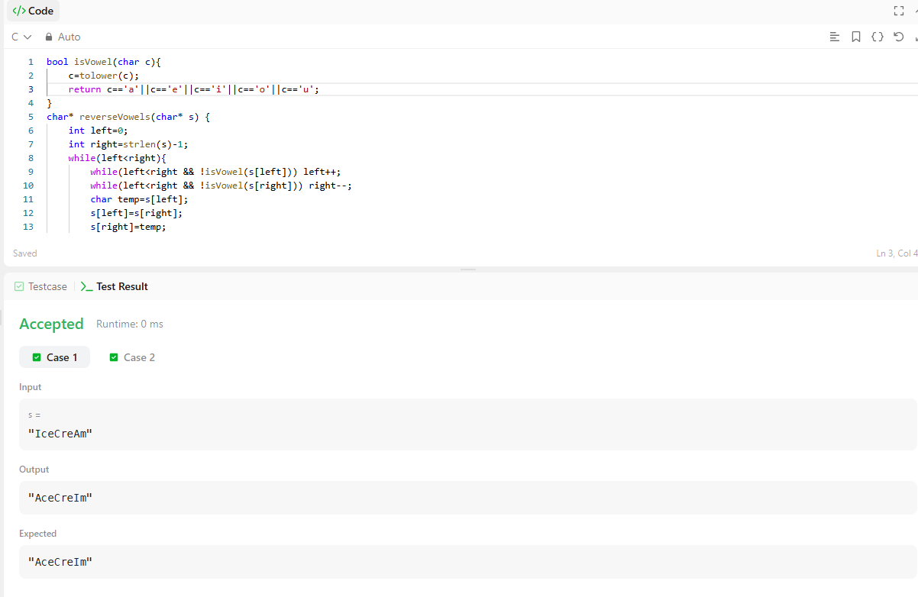
Question 2:
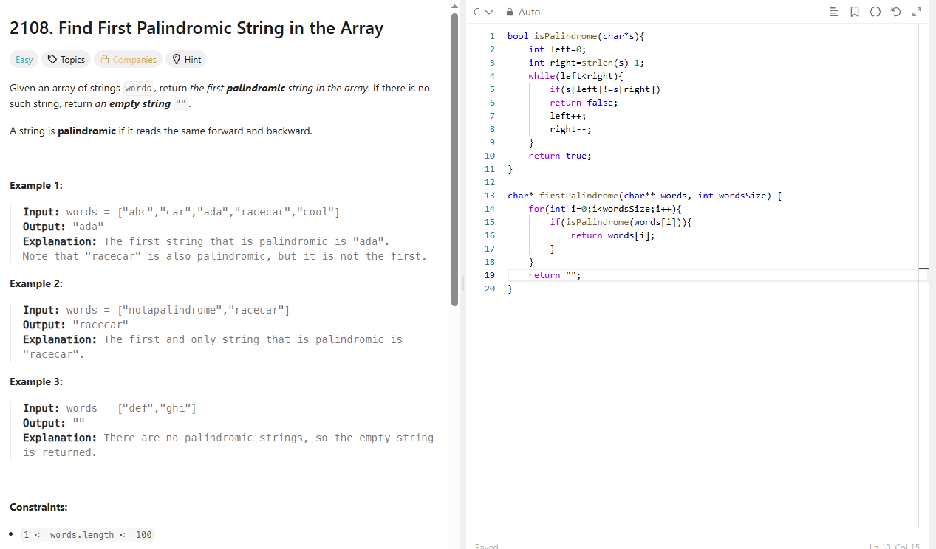

Question 3:
void rotate(int** matrix, int matrixSize, int* matrixColSize) {
int n=matrixSize;
for(int i=0;i<n;i++){
for(int j=i+1;j<n;j++){
int temp=matrix[i][j];
matrix[i][j]=matrix[j][i];
matrix[j][i]=temp;
}
}
for(int i=0;i<n;i++){
int left=0,right=n-1;
while(left<right){
int temp=matrix[i][left];
matrix[i][left]=matrix[i][right];
matrix[i][right]=temp;
left++;
right--;
}
}
}

